SQL Test Automation Program for Database Courses at Ara Institute of Canterbury

Aditya Raj

Department of Business and Digital Technologies

Ara Institute of Canterbury

adityawelly@gmail.com

Amit Sarkar

Department of Business and Digital Technologies

Ara Institute of Canterbury

amit.sarkar@ara.ac.nzAlister Macgregor

Department of Business and Digital Technologies

Ara Institute of Canterbury

*alister.macgregor@ara.ac.nz*

ABSTRACT

This paper describes the methods used to create the working Windows program for database courses at Ara Institute of Canterbury. The SQL Test Automation program serves to automate the bulk marking of SQL Server practical tests done by the students of database courses at Ara Institute of Canterbury. This program has been developed to speed up the marking process for tutors of SQL Server database courses in which student work is marked automatically and instantly, not only reducing time and manual work for tutors, but students also benefit by receiving their results much faster. This program reduces the time taken to mark a class of 25 students work from 10 working days, down to approximately 1 minute.

**Keywords**: SQL Server, Windows Application, Database, Test Automation, tSQLt Database Unit Testing Framework.

# INTRODUCTION

This project has aimed to deploy a product that allows students in database courses at Ara to submit their SQL Server language code work and get automated marks and feedback quickly.

The usage of the program is a process, firstly the tutor must connect to the local SQL Server with the database used for the practical test, upload a model answer script which must be created using the provided template and uploaded to the program, this will be used to compare with the student answers. Then the tSQLt testing script must be uploaded, which must also be created using the provided template, this script makes the program work by doing the comparison between the model and student answers.

Finally, the tutor can select a directory with all the student answer SQL files, which the program uploads and executes one by one and outputs the results in a new subdirectory named “StudentAnswerResults”. The results are outputted as text files. They can then open the new subdirectory with the click of the “Open Student Results” button, the tutor can then review those text files which contain the student results and feedback for the incorrect answers.

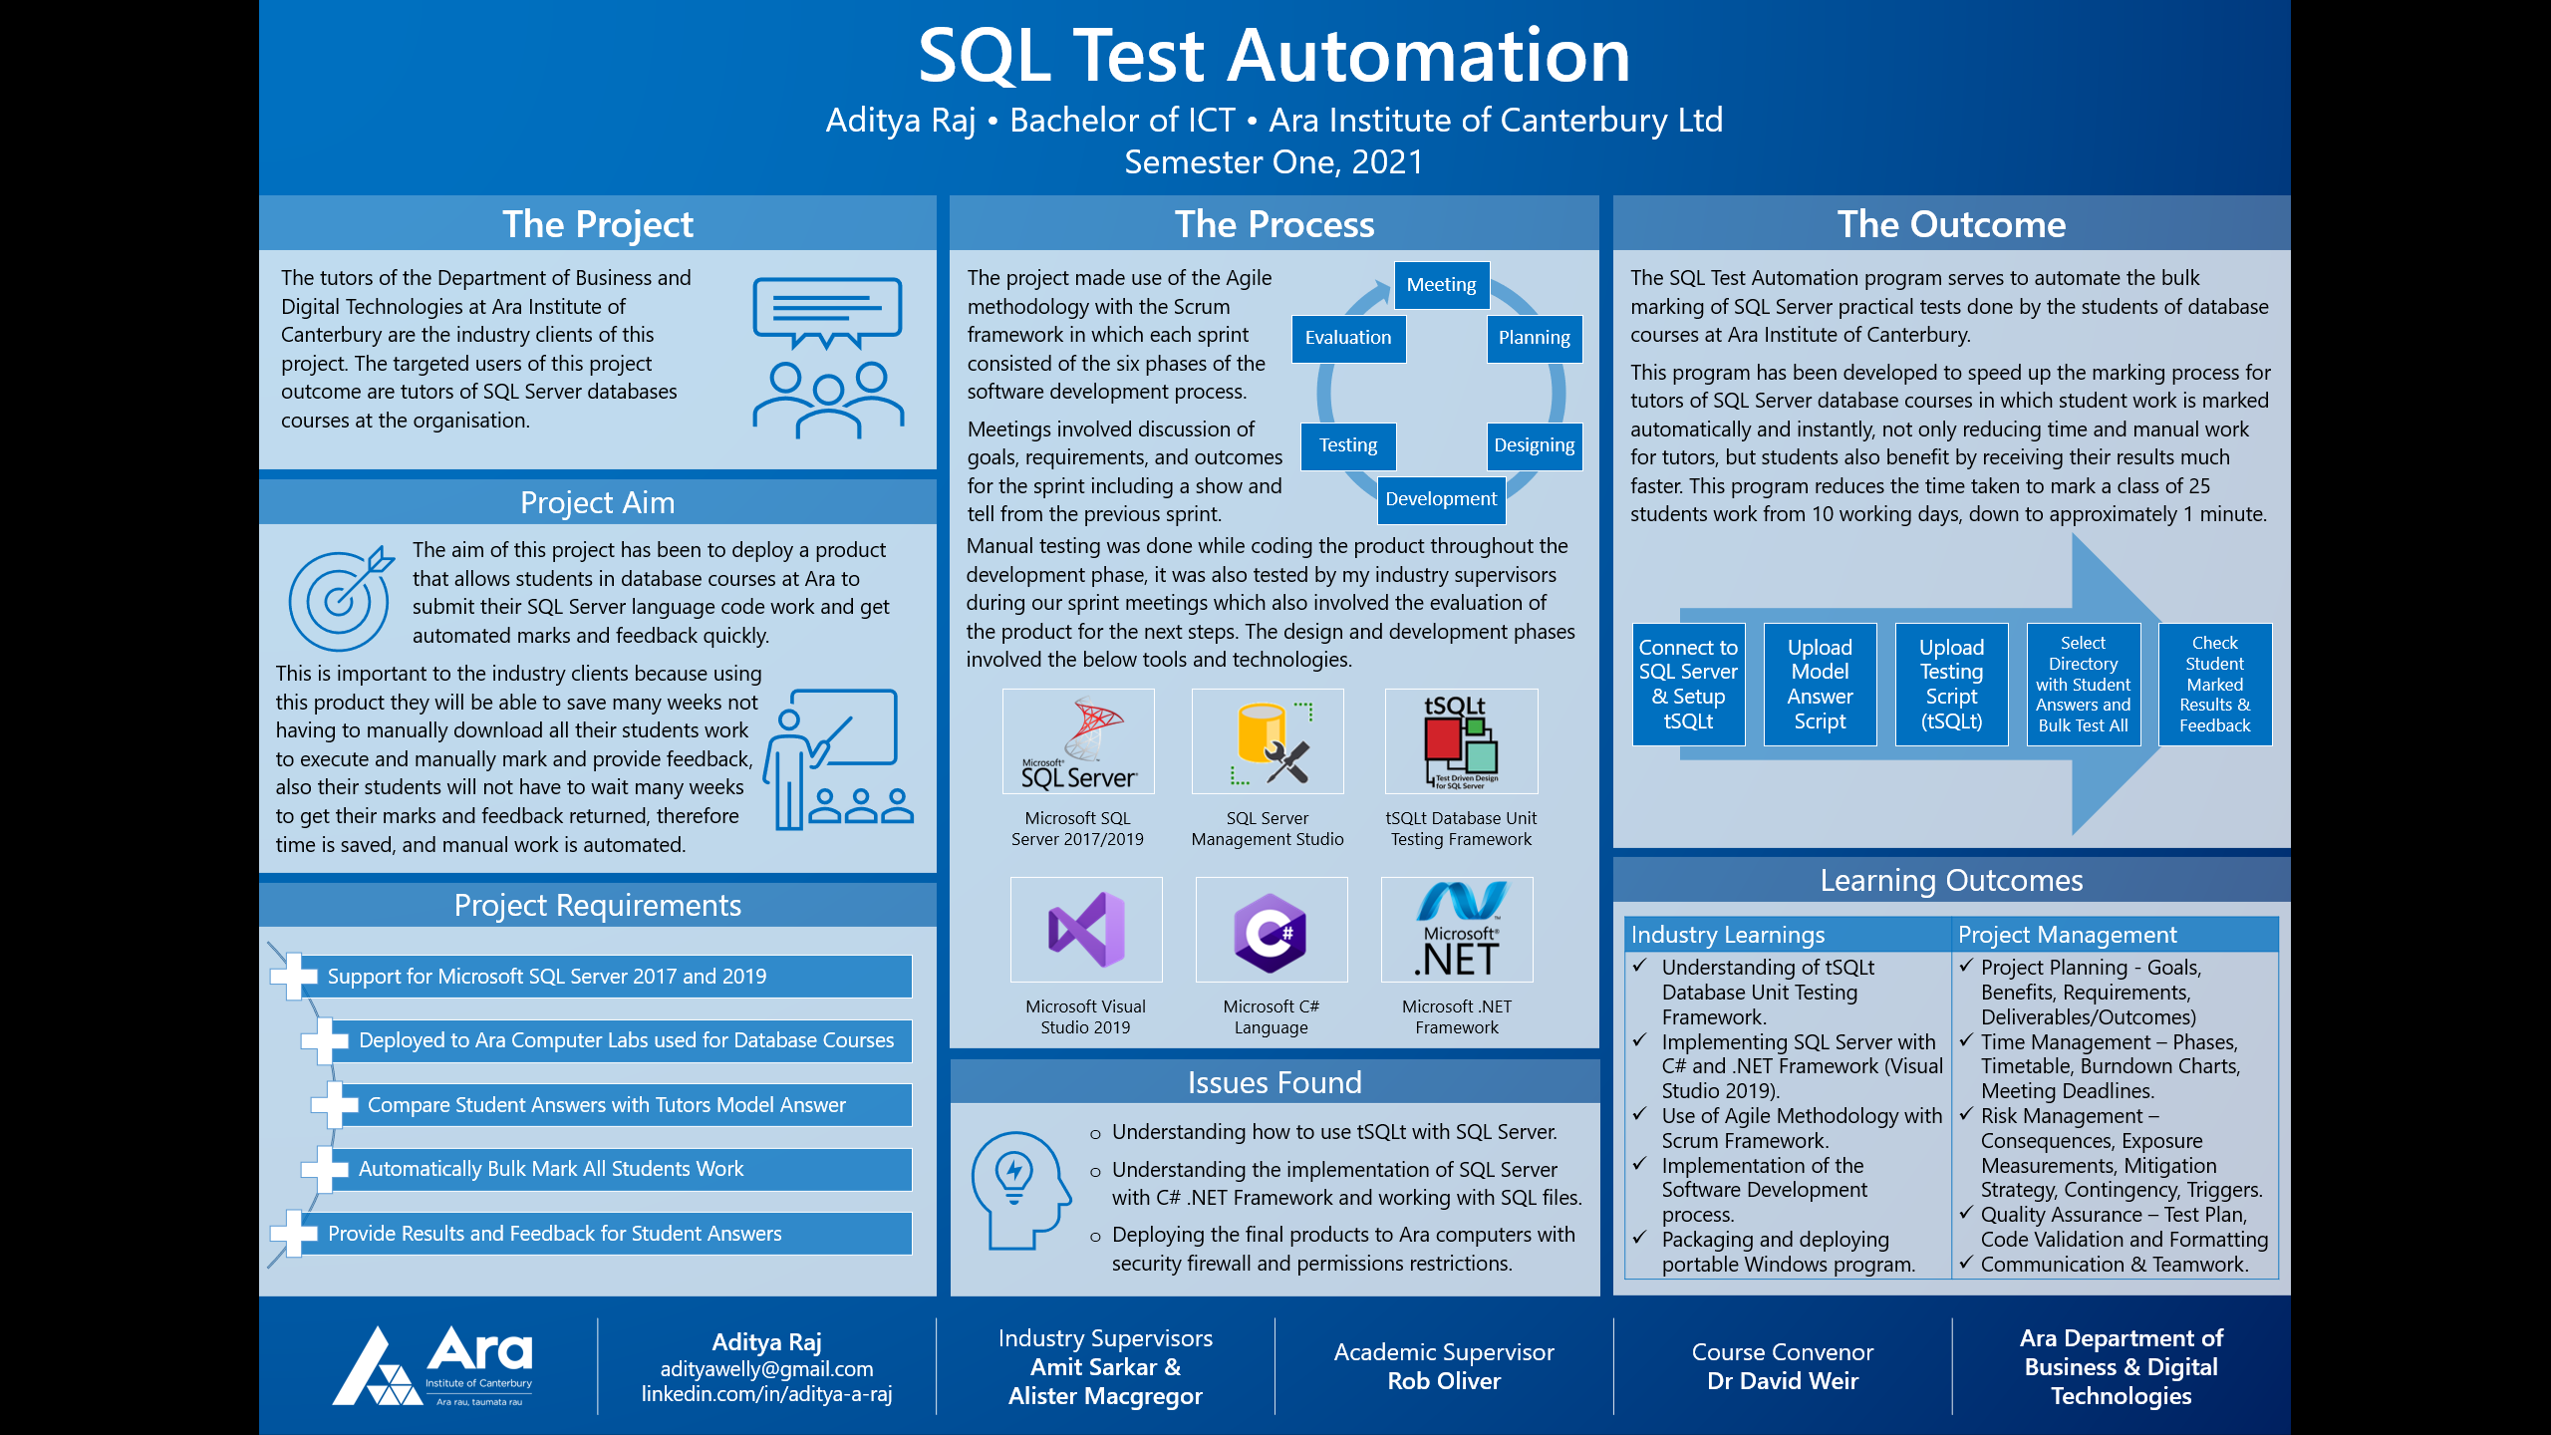

# BACKGROUND

The tutors of the Department of Business and Digital Technologies at Ara Institute of Canterbury are the industry clients of this project. The targeted users of this project outcome are tutors of SQL Server databases courses at the organisation.

The SQL Test Automation program serves to automate the bulk marking of SQL Server practical tests done by the students of database courses at Ara Institute of Canterbury.

This program has been developed to speed up the marking process for tutors of SQL Server database courses in which student work is marked automatically and instantly, not only reducing time and manual work for tutors, but students also benefit by receiving their results much faster. This program reduces the time taken to mark a class of 25 students work from 10 working days, down to approximately 1 minute.

# PROCESS

The project involves the use of the Agile methodology with Scrum framework, an incremental development framework that allows for teams to collaborate while working on complex projects. This project applies the Agile methodology with Scrum because of its many advantages that help satisfy the requirements of the company project unlike other methodologies such as the Waterfall which because of its linear process does not allow for constant improvement and innovation for products in the ever-changing software market (Muslihat, 2018). Within each sprint, the Software Development process was implemented.

The first phase involved meeting the industry supervisors to analyse and plan for the sprint. The planning included the connection of the project to the company’s goals, the resources and time required and the scheduling of tasks. The planning involved the requirements, which includes the details of the product, the reasoning behind it and how it will come together according to the client (MacKay, 2019).

With the planning and requirements complete, the design and development began, this could include prototypes, user stories, wireframes, etc. The development of the software begins keeping in mind to avoid scope creep and building clean and efficient software according to the planning, requirements, and designs (MacKay, 2019).

Testing happened during the development phase while keeping track of bugs and errors. Once the features are complete and the product is ready, more in-depth testing is recommended before moving forward. Evaluation happened and changes were issued for the next sprint through the show and tells. The process then restarts for the next sprint.

# CONCLUSION

The project outcomes were unknown at the beginning of the project. There was an unclear understanding of what was needed to produce for the outcomes of this project, it took time to not only learn the tools and technologies involved, but it also took time to figure out the expected outcomes of this project, however, these were understood from what the industry supervisors needed, I have been successful at meeting their requirements at the end of the project where I have produced the completed, viable and deployable product.

In terms of the implementation of the Agile methodology, Scrum framework and the software development process within each sprint, I was able to follow these processes throughout the project without any issues. The industry supervisors made sure that I was completing each sprint to standard with quality assurance and testing, they have been happy with my progress.

Even though this project has been a challenge for me, I have enjoyed working on it, learning new skills, and gaining knowledge with these processes, technologies, and tools. It has been a unique experience, something that I had never done before.

# References

MacKay, J. (2019, October 2). *Software Development Process: How to Pick The Process That’s Right For You.* Retrieved May 3, 2021, from Plan.io: https://plan.io/blog/software-development-process/

Muslihat, D. (2018, March 2). *Agile Methodology: An Overview.* Retrieved April 3, 2021, from Zenkit: https://zenkit.com/en/blog/agile-methodology-an-overview/